Find the makers from Product producing PCs but not laptops.

Product

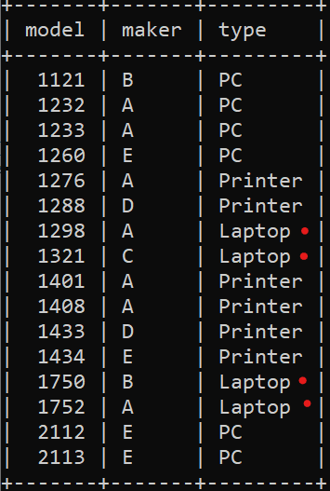

Ответ:

**select DISTINCT maker from product WHERE maker NOT IN (SELECT maker FROM product WHERE type = 'Laptop') and type = 'pc';**